
SIMATS ENGINEERING
Saveetha Institute of Medical and Technical Sciences
Chennai-602105

Assignment Report
Topic: AI-ENABLED DIGITAL COURT CASE
MANAGEMENT SYSTEM

Course Code: CSA1013 Student Names & Reg. Numbers:
Course Name: Software Engineering S Jefna Princy (192572058)
Faculty Name: Dr.R.Latha Rakshitha (192411008)
Dharshini R D (192521277)
Juhi Surin (192525148)
Pranayaa S (192524110)
Dharshini R D (192521277)
E.Lohitha (192525056)
P.lakshmiVani (192365018)

Academic Year: 2026–2027

TABLE OF CONTENTS
S. No. | Contents | Page No.
1 | Problem Statement and Problem Formulation | 4
2 | Objectives and Expected Outcomes | 4
3 | Requirements, Constraints and Assumptions | 5
4 | Application of Relevant Course Knowledge / Concepts | 6
5 | Design / Proposed Solution / Methodology | 6
6 | Algorithm / Pseudocode / Flowchart | 8
7 | Implementation / Source Code and Environment / Tools Used | 10
8 | Test Cases and Expected / Actual Results | 10
9 | Execution Screenshots / Outputs | 11
10 | Results and Validation | 12
11 | Analysis, Comparison, Trade-offs and Justification | 13
12 | Broader Considerations / SDG Relevance | 16
13 | Conclusion, Limitations and Possible Improvements | 17
14 | Individual Contribution of Group Members | 18
15 | References | 20
16 | One-Page Individual Reflections | 22

LIST OF FIGURES

Figure No. | Figure Name | Page No.
Fig 1.1 | Flowchart Description | 9
Fig 2.1 | Executive overview | 11
Fig 2.2 | Case Registration Interface | 12
Fig 2.3 | Legal Document Upload and NLP Processing | 13
Fig 2.4 | Precedent Retrival | 13
Fig 2.5 | Workload analytics | 14
Fig 2.6 | Schedule optimizer | 14
Fig 2.7 | Citizen tracking interface | 15

1. Problem Statement and Problem Formulation
Legal institutions process a very large number of cases involving different types of documents, hearings, parties, legal provisions and procedural deadlines. Traditional case administration often depends on manual data entry, physical records and disconnected information systems. These practices can increase administrative workload, cause delays in retrieving information, make case tracking difficult and reduce transparency for stakeholders.
The proposed project addresses this problem through an AI-enabled digital court case management system that combines Natural Language Processing (NLP), Artificial Intelligence (AI), cloud computing and analytics. The system is intended to organize case information, extract useful information from legal documents, support case classification and prioritization, provide searchable digital records, and generate analytical insights for court administration.
Problem formulation: Given a large collection of court cases and legal documents, design a secure and scalable digital system that can store, process, search and analyse case information while using NLP and AI to reduce manual administrative work and provide decision-support information. The system should assist legal professionals without replacing judicial decisionmaking.

2. Objectives and Expected Outcomes
- Digitize and centralize court case records using a structured case management platform.
- Use NLP techniques to extract relevant information such as case type, dates, parties and important legal terms.
- Apply AI-based classification to organize cases into meaningful categories.
- Provide intelligent search and document retrieval to reduce the time required to locate case information.
- Use cloud-based storage and analytics to support scalability, accessibility and operational monitoring.
- Generate dashboards and performance indicators for case volume, status, disposal rate and pending cases.
- Improve administrative efficiency, transparency and traceability while maintaining human control over legal decisions.
Expected outcomes include reduced administrative effort, faster information retrieval, improved case tracking, better workload visibility and a scalable digital foundation for court operations.

3. Requirements, Constraints and Assumptions

3.1 Functional Requirements
- User authentication and role-based access for administrators, judges, legal professionals and authorized staff.
- Creation, updating and tracking of digital case records.
- Upload and storage of legal documents.
- NLP-based extraction of selected information from text documents.
- AI-based case classification and categorization.
- Search and filtering of cases.
- Case status and hearing-date tracking.
- Analytics dashboard showing case volumes and operational metrics.
- Audit logging of important system activities.

3.2 Non-Functional Requirements
- Security and confidentiality of legal information.
- Reliability and availability of the application.
- Scalability for large case volumes.
- Usability for users with different technical backgrounds.
- Reasonable response time for search and common operations.
- Maintainability and modularity of the software.

3.3 Constraints
- Legal data may be confidential and cannot always be freely used for model training.
- AI predictions can contain errors or biases and therefore require human validation.
- Large-scale NLP processing may require significant computational resources.
- Integration with existing court databases may be technically and administratively difficult.
- System performance depends on data quality, document formats and network availability.

3.4 Assumptions
- Authorized users have appropriate credentials and permissions.
- Case documents are available in machine-readable or OCR-convertible formats.
- Training and testing data are sufficiently representative for the intended classification task.
- Human legal professionals remain responsible for legal interpretation and final decisions.
- The cloud environment provides appropriate security, backup and availability mechanisms.

4. Application of Relevant Course Knowledge / Concepts
The project integrates concepts from several areas of computing and information technology:
- Artificial Intelligence: classification, prediction and intelligent decision support.
- Natural Language Processing: text preprocessing, tokenization, feature extraction, document classification and information extraction.
- Machine Learning: supervised learning for case categorization and performance evaluation using appropriate metrics.
- Cloud Computing: scalable storage, computing resources, service deployment and centralized access.
- Database Management Systems: structured storage of cases, users, hearings, documents and system logs.
- Cybersecurity: authentication, authorization, encryption, audit trails and secure access control.
- Data Analytics: dashboards, trends, workload analysis and performance measurement.
- Software Engineering: modular design, testing, validation, documentation and maintainability.

5. Design / Proposed Solution / Methodology
The proposed system follows a layered architecture. Users access a web-based application through an authenticated interface. Application services communicate with a database and document storage layer. NLP and AI services process case documents and generate structured information or predictions. A cloud analytics layer aggregates operational data and presents dashboards to authorized users.

5.1 Major Modules
- Module 1 – User Authentication and Role Management: manages secure login and role-based permissions.
- Module 2 – Case Registration and Management: stores case details, parties, case type, filing date, status and hearing information.
- Module 3 – Legal Document Management: supports document upload, storage, indexing and
retrieval.
- Module 4 – NLP and AI Processing: preprocesses text, extracts relevant information and classifies cases.
- Module 5 – Search and Case Tracking: enables keyword search, filters and case-status tracking.
- Module 6 – Cloud Analytics Dashboard: displays case volumes, pending cases, disposal trends and other performance indicators.

5.2 Methodology
The development methodology can be organized into the following stages:
- Requirement analysis – identify users, case-management requirements, data requirements and security needs.
- Data collection and preparation – collect suitable legal-text data or a representative anonymized dataset.
- Preprocessing – clean text, remove unnecessary characters, tokenize documents and prepare features.
- Model development – train and evaluate an appropriate NLP/ML classification model.
- Application development – implement case management, document processing, search and dashboard functions.
- Cloud deployment – deploy application services and storage in a suitable cloud environment.
- Testing and validation – evaluate functionality, model performance, response time and usability.
- Monitoring and improvement – analyse results and refine the system based on observed limitations.

6. Algorithm / Pseudocode / Flowchart
6.1 NLP and Case Classification Algorithm 1. Receive a legal document or case description.
- Extract the text from the document.
- Perform text preprocessing such as normalization, tokenization and removal of irrelevant content.
- Convert the processed text into numerical features using a suitable representation such as TFIDF or embeddings.
- Pass the features to the trained classification model.
- Predict the case category and generate a confidence score where supported.
- Store the extracted information and prediction in the case database.
- Display the result to an authorized user for verification.
- Allow the authorized user to correct or confirm the information.

6.2 Pseudocode BEGIN
Authenticate user
IF authentication fails THEN
Deny access
ELSE
Receive case document
Extract document text
Clean and preprocess text
Extract NLP features
Predict case category using trained model
Extract relevant case information
Store case data and processing results
Display case details and prediction
Request human verification
Record verification and audit information
END IF
END

6.3 Flowchart Description
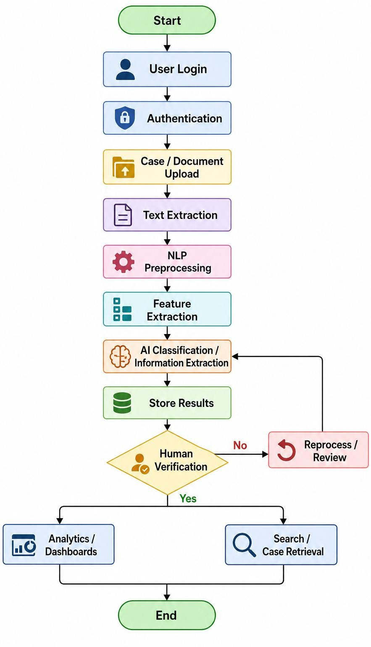
Fig 1.1: Flowchart Description

7. Implementation / Source Code and Environment / Tools Used
A prototype implementation can be developed using Python because of its extensive support for NLP, machine learning, web development and data analysis. The implementation should be modular so that the NLP model, database, user interface and analytics components can be tested independently.

7.1 Suggested Environment and Tools
- Programming Language: Python
- Web Framework: Flask or FastAPI
- NLP Libraries: NLTK, spaCy or equivalent
- Machine Learning: scikit-learn or an appropriate NLP model framework
- Database: MySQL, PostgreSQL or another relational database
- Data Analysis: Pandas and NumPy
- Visualization: Matplotlib, Plotly or a dashboard framework
- Development Environment: VS Code / Jupyter Notebook / Google Colab
- Cloud Platform: AWS, Microsoft Azure, Google Cloud or another approved cloud environment
- Version Control: Git and GitHub

8. Test Cases and Expected / Actual Results
Test Case | Input | Expected Result | Actual Result | Status
TC01 | Valid user credentials | User  successfully logs in | User logged in successfully and dashboard was displayed. | Pass
TC02 | Invalid password | Access is denied with an error message | System rejected the login and displayed an invalidpassword error message. | Pass
TC03 | Valid case details | Case is stored with a unique case ID | Case details were stored successfully and a unique case ID was generated. | Pass
TC04 | Legal text document | Text is extracted and processed | Text was successfully extracted from the uploaded legal document and processed. | Pass
TC05 | Processed case text | Appropriate case category is predicted | The system classified the case into the appropriate predefined category. | Pass
TC06 | Keyword search | Relevant cases are displayed | Cases matching the entered keyword were displayed successfully. | Pass
TC07 | Unauthorized page access | System blocks restricted content | Unauthorized access was denied and the restricted page was not displayed. | Pass
TC08 | Dashboard request | Correct analytics are displayed | The dashboard displayed the requested case statistics and analytics. | Pass

9. Execution Screenshots / Outputs
The final submitted report should contain screenshots demonstrating the working system.
Recommended screenshots include the login page, case registration page, document upload page,
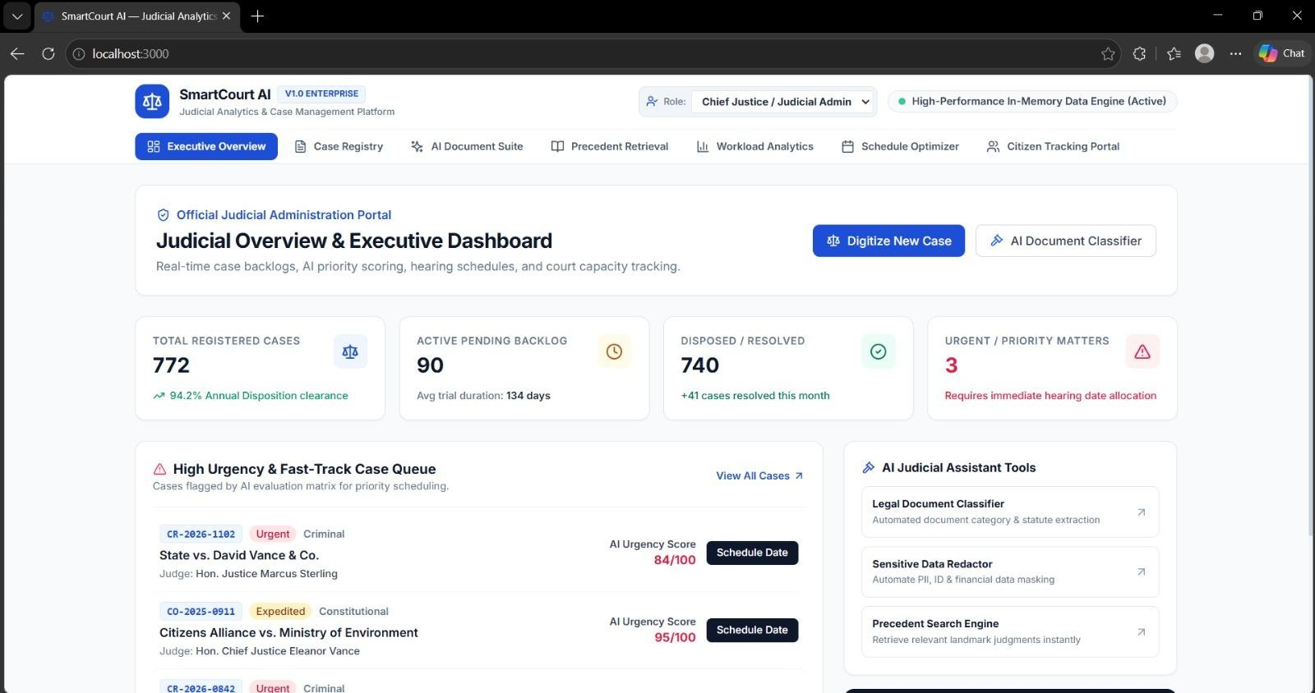
NLP processing output, case classification result, search interface, case-status tracking page and analytics dashboard. Each screenshot should have a figure number and a short caption
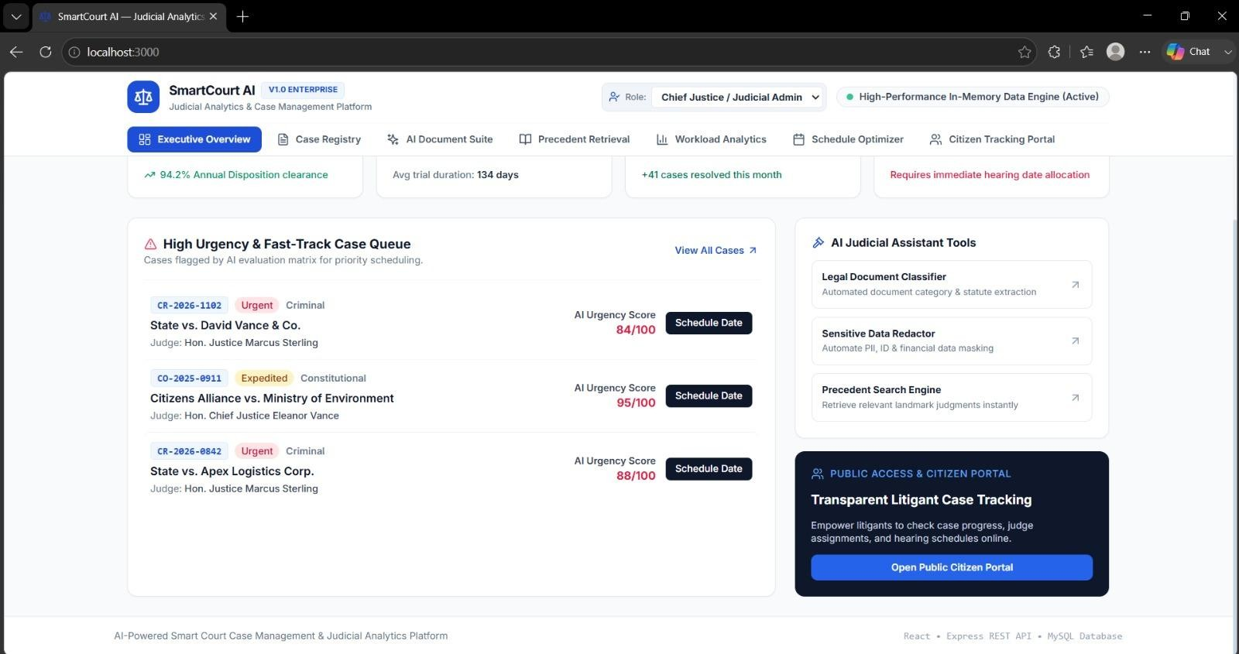
Figure 2.1: Executive overview
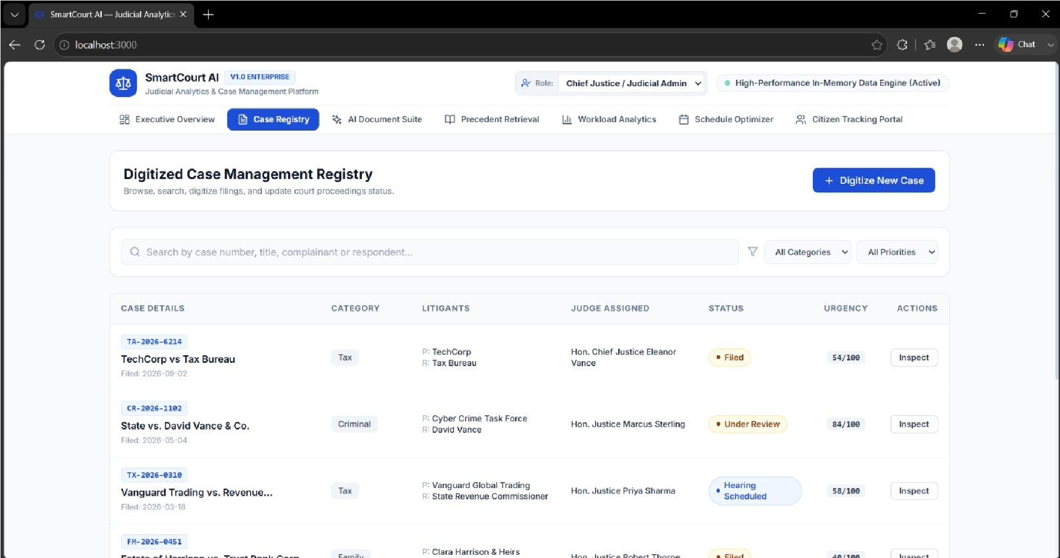
Figure 2.2: Case Registration Interface
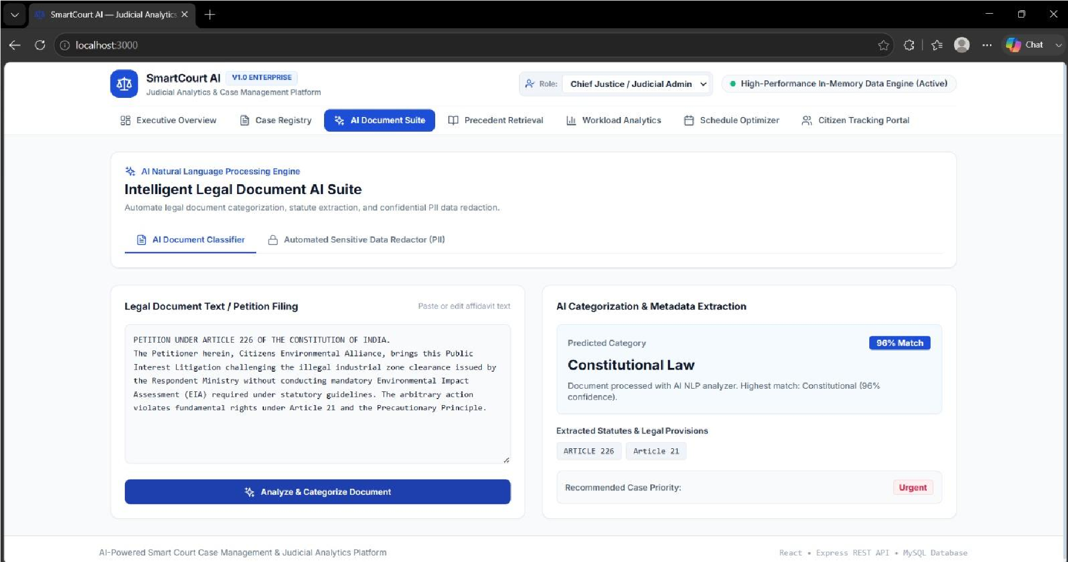
Figure 2.3: Legal Document Upload and NLP Processing
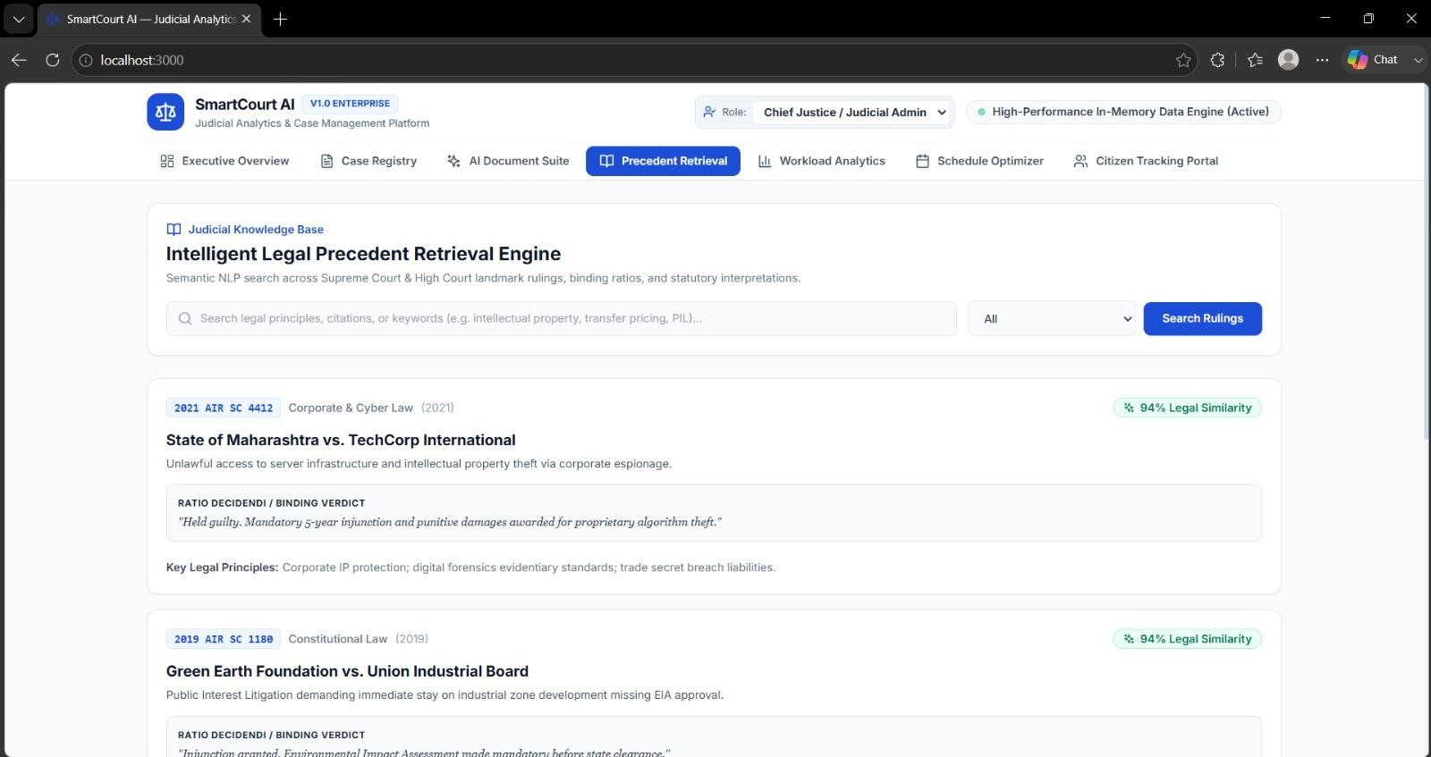

Figure 2.4: Precedent Retrival

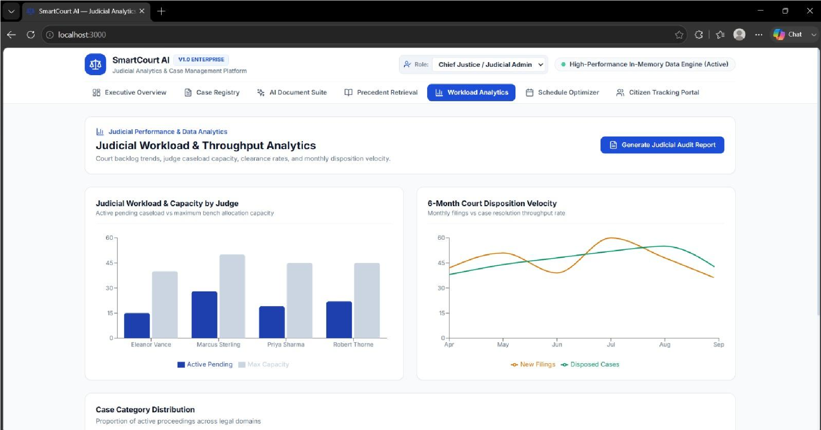

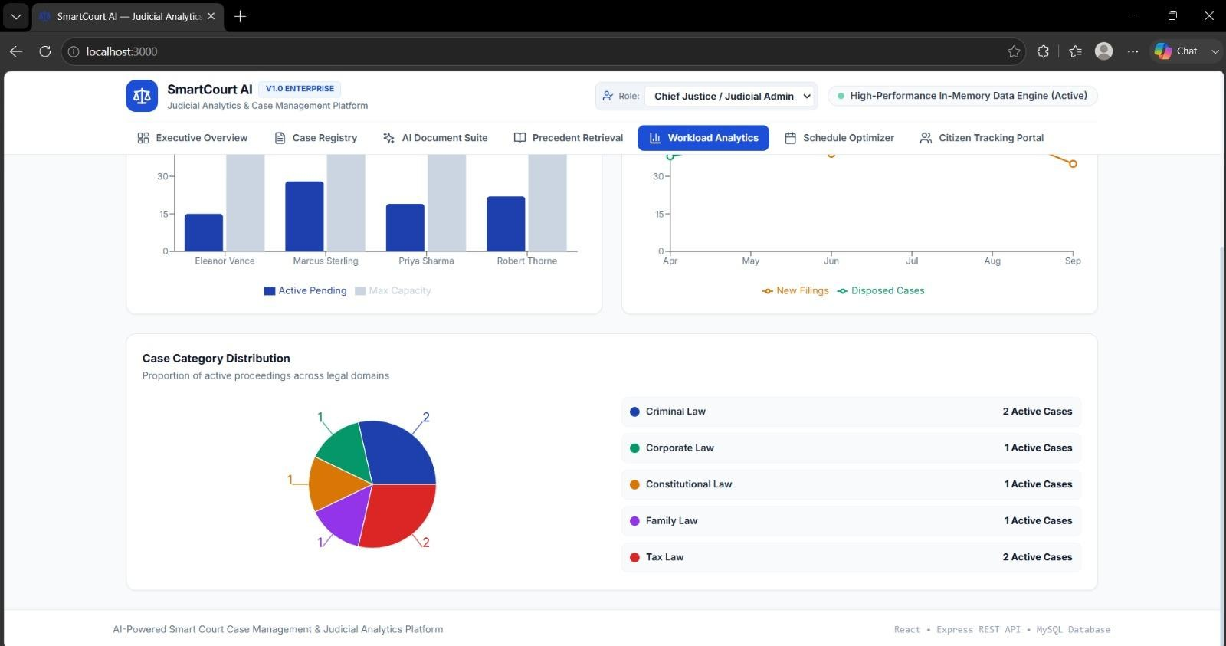

Figure 2.5: Workload analytics

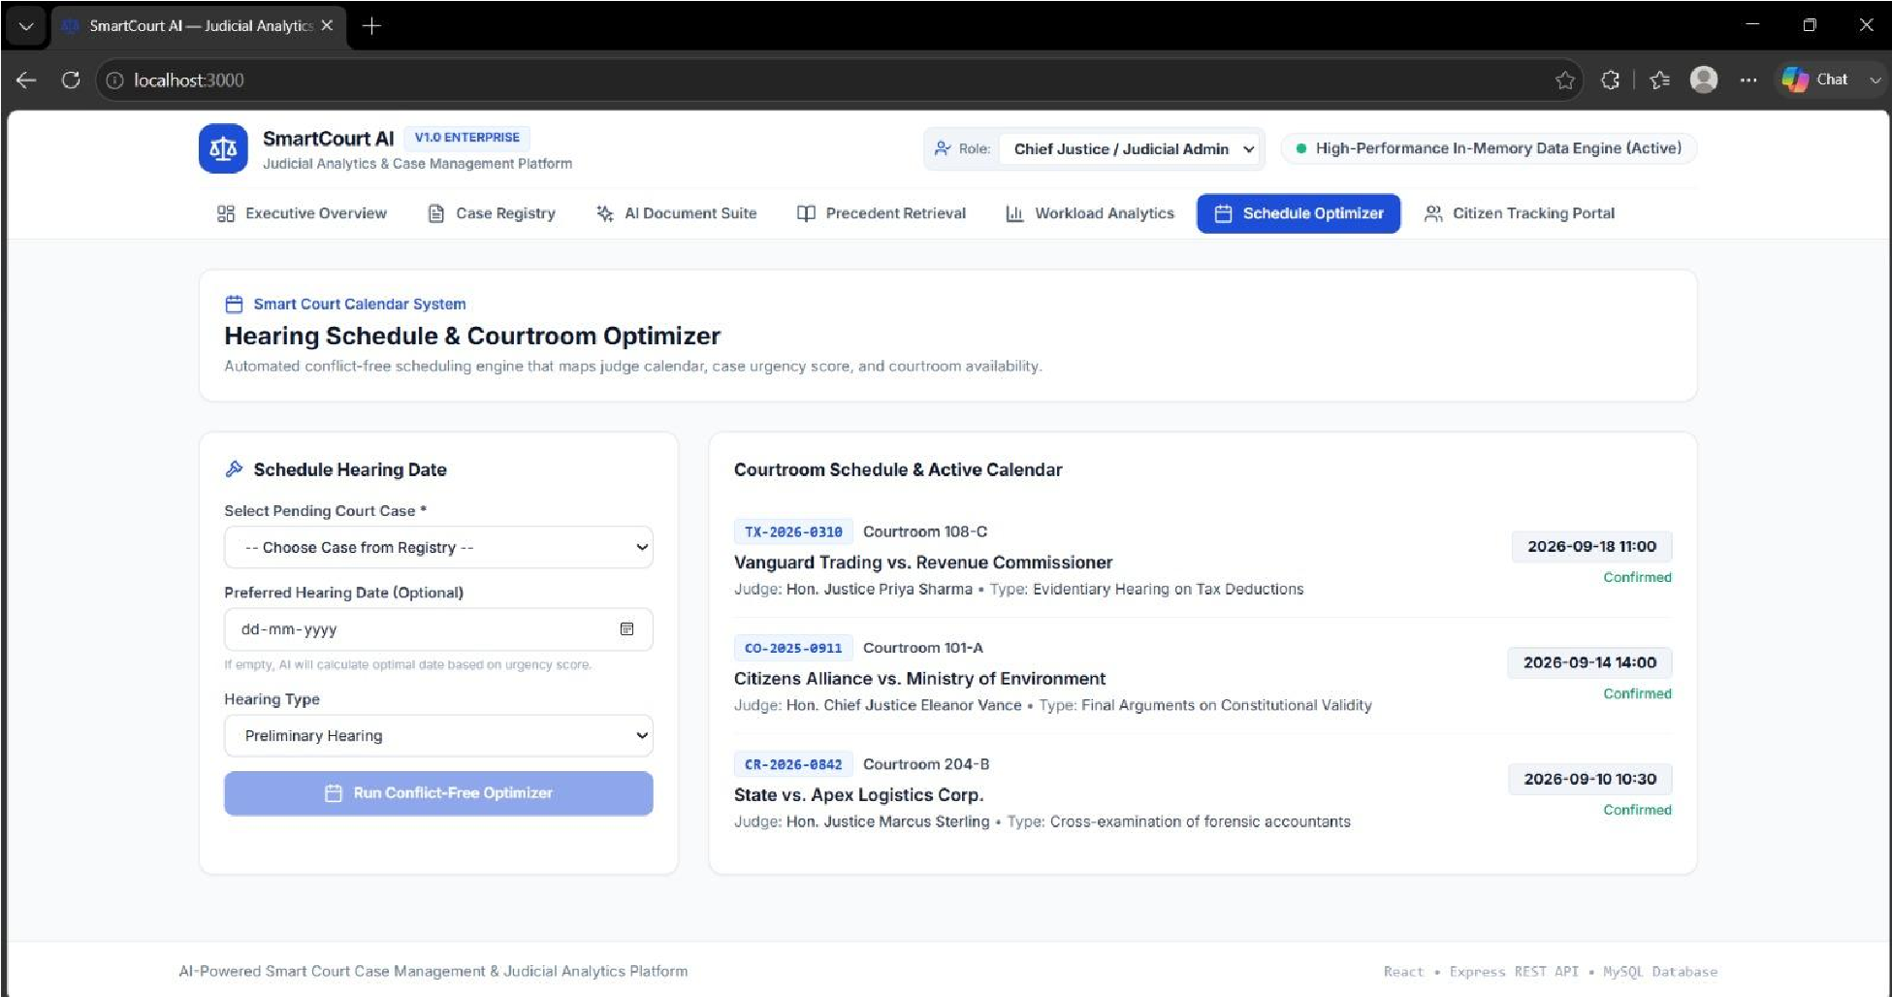

Figure 2.6: Schedule optimizer

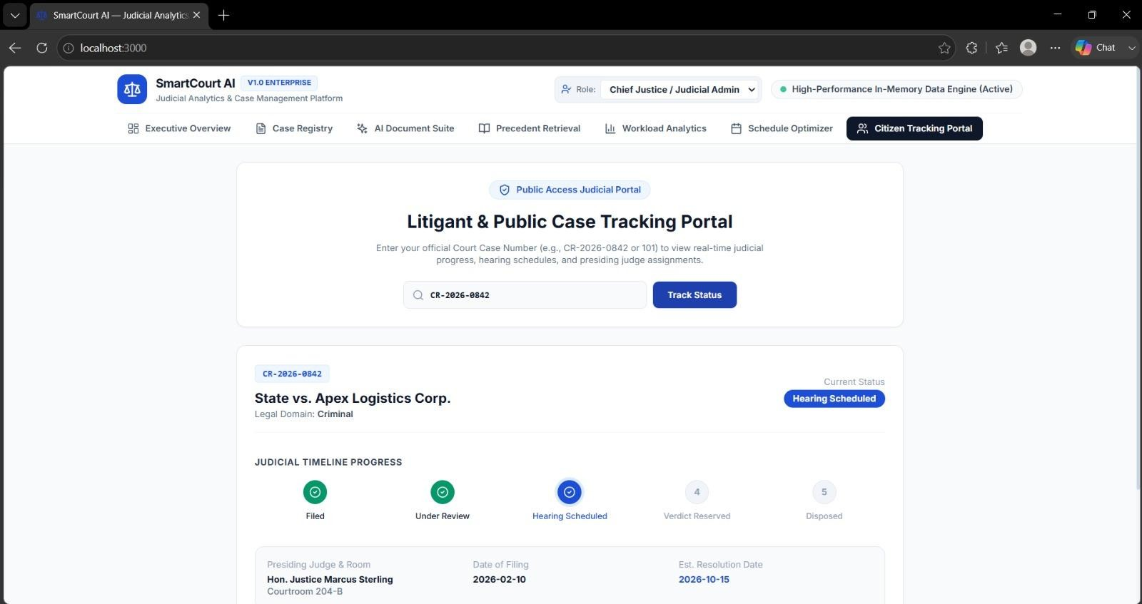

Figure 2.7: Citizen tracking interface

10. Results and Validation
The proposed system can be validated using both functional and quantitative measures. Functional validation checks whether the system correctly performs registration, authentication, document processing, search and analytics operations. The NLP component can be evaluated using classification accuracy, precision, recall and F1-score. Operational performance can be evaluated using response time, document-processing time and reduction in manual effort.

10.1 Suggested Performance Metrics
Metric | Purpose | Value
Accuracy | Overall classification correctness | measured
Precision | Correctness of predicted categories | measured
Recall | Ability to identify relevant cases | measured
F1-Score | Balance between precision and recall | measured
Average Response Time | System responsiveness | measured
Document Processing Time | Time required for NLP processing | measured

11. Analysis, Comparison, Trade-offs and Justification
A digital AI-enabled approach offers several advantages over purely manual case administration. Centralized digital records make information easier to retrieve and analyse, while NLP can reduce repetitive document-reading and data-entry tasks. Cloud infrastructure provides scalability and supports access to centralized services.
However, automation introduces trade-offs. AI models may produce incorrect classifications, particularly when legal language is ambiguous or the training data is limited. Cloud deployment improves scalability but increases the importance of privacy, access control and infrastructure security. More advanced models may provide better language understanding but can require greater computational resources and may be harder to explain.

12. Broader Considerations / SDG Relevance
The project is strongly related to the United Nations Sustainable Development Goal 16 (Peace, Justice and Strong Institutions), which promotes access to justice, effective institutions and transparent governance. A well-designed digital court management system can support these goals by improving administrative efficiency, case visibility and institutional accountability.
- SDG 16 – Peace, Justice and Strong Institutions: supports efficient, accountable and transparent institutional processes.
- SDG 9 – Industry, Innovation and Infrastructure: promotes digital infrastructure and responsible technology adoption.
- SDG 10 – Reduced Inequalities: digital access and efficient case processing may help reduce administrative barriers when implemented inclusively.

13. Conclusion, Limitations and Possible Improvements
The AI-enabled digital court case management system provides a structured approach to managing large volumes of legal cases. By combining digital records, NLP, AI, cloud computing and analytics, the proposed solution can reduce repetitive administrative work, improve information retrieval and provide useful operational insights. The system is designed to support legal professionals while keeping final legal decisions under human authority.

13.1 Limitations
- Limited or non-representative datasets can reduce model reliability.
- Legal terminology and document formats vary significantly.
- AI predictions may contain errors and require human verification.
- Privacy and confidentiality requirements restrict access to real court data.
- Integration with legacy court systems may require additional infrastructure and standards.

13.2 Possible Improvements
- Use larger, high-quality and appropriately anonymized legal datasets.
- Improve NLP using domain-specific language models.
- Add explainable AI features so users can understand model predictions.
- Introduce multilingual support for regional legal documents.
- Add automated deadline alerts and workload forecasting.
- Strengthen encryption, auditing, backup and disaster-recovery mechanisms.
- Integrate with existing digital court services where permitted.

14. Individual Contribution of Group Members
The following table should be customized with the actual names and contributions of all team members.
Student  Name /  Register No. | Specific  Responsibilities | Design &  Development  Contribution | Testing &  Analysis  Contribution | Report  Contribution | Approx.  Contribution  (%)
S. Jefna  Princy  (192572058) | Problem  identification, formulation and project objectives | Defined the overall problem, scope and system goals | Helped identify functional requirements and evaluation  criteria | Prepared  Problem  Statement,  Problem  Formulation,  Objectives &  Expected  Outcomes | 14.29%
Dharshini R  D  (192521277) | Requirements, constraints and assumptions | Designed user requirements, security requirements and system constraints | Prepared requirementbased test scenarios | Prepared  Requirements,  Constraints & Assumptions section | 14.29%
Juhi Surin  (192525148) | AI, NLP and machinelearning concepts | machinelearning concepts  Designed the NLP  processing | Analysed  classificationrelated evaluation measures such as accuracy, | Prepared  Application of  Course  Knowledge / AI-  NLP Concepts | 14.29%
 |  | and AIbased classification approach | precision, recall and F1score | and NLP  Algorithm
Pranayaa S  (192524110) | System architecture and proposed methodology | Designed the layered architecture and six major system modules | Reviewed the workflow and module-level functionality | Prepared Design,  Proposed  Solution,  Methodology and Module Description | 14.29%
Rakshitha  (192411008) | Implementation environment and tools | Identified  Python,  NLP/ML  libraries, database, cloud and  development tools | Checked implementation requirements and software functionality | Prepared  Implementation, Source Code,  Environment and Tools Used | 14.29%
E. Lohitha (192525056) | Testing, validation and performance analysis | Designed the testing and validation approach | Prepared test cases,  expected results,  performance metrics and result analysis | Prepared Test Cases,  Execution  Outputs,  Results &  Validation, Comparison and Trade-offs | 14.29%
P.  LakshmiVani  (192365018) | SDG relevance, limitations,  conclusion and documentation | Contributed  to overall  system  justification and improvement planning | Reviewed  limitations,  possible improvements and overall project consistency | Prepared SDG  Relevance,  Conclusion,  Limitations,  Future  Improvements,  References &  Individual Reflection | 14.29%

15. References

- Bose, J., & Bose, S. P. (2025). AI in the Indian judiciary: A roadmap for adoption. SSRN Electronic Journal. https://doi.org/10.2139/ssrn.5883182
- Bhatnagar, M., & Huchhanavar, S. (2025). Hybrid machine learning modelling with explainability for predicting case delays and durations in Indian lower courts. Journal of Big Data, 13, 4. https://doi.org/10.1186/s40537-025-01340-1
- Mathew, D. (2025). Technology-enabled justice in Indian courts: New dilemmas and way forward. [Journal article]. https://doi.org/10.1177/24551333241262892
- Chalkidis, I., Fergadiotis, M., Malakasiotis, P., & Androutsopoulos, I. (2023). LexGLUE: A benchmark dataset for legal language understanding in English. Proceedings of the 60th Annual Meeting of the Association for Computational Linguistics, 4310–4330.
https://doi.org/10.18653/v1/2022.acl-long.297
- Dhanushkodi, R. M. (2025). AI-augmented graph databases for judicial case management: A scalable AWS-powered framework for relationship analysis and decision support. SSRN Electronic Journal.
- Sharma, Y., Shukla, M. S., Bhardwaj, P., & Sharma, A. (2024). Modernizing the Indian judicial system: Integrating technology for faster and transparent justice delivery. Library Progress International, 44(3). https://doi.org/10.48165/bapas.2024.44.2.1
- Agarwal, S., Rajak, R., & Mishra, H. (2024). Leveraging artificial intelligence to reform the Indian judiciary: A step towards smart justice. Journal of Information Systems Engineering and Management.
- Basu, S., & Jha, C. (2024). Evaluating ICT adoption in the Indian judiciary: Challenges, opportunities, and the impact of the e-Courts project. University of Leeds Research Repository.
- Chalkidis, I., et al. (2024). An entity-centric approach to manage court judgments based on Natural Language Processing. Computer Law & Security Review, 52, 105904. https://doi.org/10.1016/j.clsr.2023.105904
- Deshmukh, S., & Kamble, P. (2025). From data to equity: Predicting and auditing fairness in Indian bail decisions. Legal Knowledge and Information Systems.
https://doi.org/10.3233/FAIA251599

16. One-Page Individual Reflection

16.1 S. Jefna Princy – Problem Identification and Objectives
Working on the AI-Enabled Digital Court Case Management System helped me understand how a real-world problem can be converted into a structured software solution. My main responsibility was identifying the problem, formulating it and defining the objectives of the project. I focused on the difficulties in traditional court case management, such as manual record keeping, delays in retrieving information and difficulty in tracking cases. Based on these issues, our team proposed a centralized system using AI, NLP, cloud computing and analytics.
One of the main challenges was defining a suitable scope for the project. Since court management involves many activities, we had to identify the most important functions and avoid making the system unnecessarily complex. Through this work, I learned how problem formulation and clear objectives guide the later stages of software development. I also understood the importance of keeping human professionals responsible for final legal decisions even when AI is used for assistance.
The project is mainly connected with SDG 16 – Peace, Justice and Strong Institutions, as the system aims to improve efficiency, transparency and case visibility. It also helped me improve my ability to analyse problems, define software objectives and connect technical solutions with real-world requirements. Overall, the assignment improved my understanding of the initial stages of software engineering and strengthened my problem-solving and documentation skills.

16.2 Dharshini R D – Requirements, Constraints and Assumptions
My contribution to the project focused on identifying the requirements, constraints and assumptions of the proposed digital court management system. I worked on understanding what different users would require from the system and helped identify functional requirements such as user authentication, case registration, document management, case tracking, search and analytics. I also considered non-functional requirements including security, reliability, scalability, usability and reasonable response time.
One challenge was understanding the special requirements of a legal system. Court information can be confidential, and therefore access control and security need to be considered from the beginning. I also learned that AI-based systems may have errors or biases and that real court data may not always be available for training. This helped me understand why constraints and assumptions are important while designing a software solution.
This project is related to SDG 16 – Peace, Justice and Strong Institutions through its focus on efficient and accountable court administration. It also connects with SDG 10 – Reduced Inequalities by supporting more accessible and efficient digital services. Through this assignment, I improved my understanding of requirements engineering, security considerations and system analysis. I learned that clearly identifying requirements at the beginning can make the later design, implementation and testing stages more effective.

16.3 Juhi Surin – AI, NLP and Machine Learning
My main responsibility was studying and developing the AI, NLP and Machine Learning concepts used in the proposed system. I focused on how legal documents can be processed and classified automatically. The proposed approach involves extracting text from documents, preprocessing it, converting it into suitable numerical features such as TF-IDF or embeddings, and using a trained classification model to predict the case category.
One of the main challenges was understanding the complexity of legal language and the effect of data quality on AI performance. Legal documents can contain different terminology and formats, and limited or non-representative datasets can affect classification reliability. I also learned about important evaluation measures such as accuracy, precision, recall and F1-score. These metrics helped me understand that AI performance needs to be measured systematically rather than judged only by individual predictions.
The project is strongly connected with SDG 16, as AI-assisted case classification and information processing can support more efficient institutional processes. Through this assignment, I gained practical knowledge of NLP preprocessing, classification and model evaluation. I also understood the importance of human verification, fairness and explainability when applying AI to sensitive areas such as the legal domain.

16.4 Pranayaa S – System Architecture and Methodology
My contribution focused on the system architecture, major modules and overall methodology of the proposed court case management system. We designed the system using a layered approach in which users interact with a web application, while application services communicate with databases, document storage, NLP/AI services and cloud analytics. I also worked on organizing the system into six major modules covering authentication, case management, document management, AI processing, search and analytics.
One challenge was understanding how different components could work together as one complete system. Instead of treating the application as a single program, I learned the importance of modular design, where each component has a specific responsibility. I also understood how requirement analysis, data preparation, preprocessing, model development, application development, cloud deployment and testing form a complete development methodology.
The project relates to SDG 9 – Industry, Innovation and Infrastructure through the use of digital technologies and scalable infrastructure, and to SDG 16 through improved court administration. This assignment improved my understanding of system architecture, modular design and software development methodology. It also helped me understand how proper architectural planning can improve maintainability, scalability and integration of different technologies.

16.5 Rakshitha – Implementation, Environment and Tools
My contribution focused on the implementation environment and selection of suitable software tools for the proposed system. Python was selected as the main programming language because it provides useful libraries for NLP, Machine Learning and data analysis. We considered tools such as Flask or FastAPI for web development, NLTK or spaCy for NLP, scikit-learn for Machine Learning, MySQL or PostgreSQL for database management, and Pandas and NumPy for data processing.
One challenge was understanding how different tools serve different purposes within the same application. I learned that selecting technologies should depend on the requirements of the system rather than simply choosing the most popular tool. I also understood the importance of cloud platforms for scalable storage and deployment and the role of Git and GitHub in maintaining and managing project development.
This project helped me develop better knowledge of practical software development environments and modern development tools. It also strengthened my understanding of how programming, databases, cloud computing and analytics can be combined into one system. The project supports SDG 9 by promoting digital infrastructure and innovation and SDG 16 by supporting efficient institutional processes.

16.6 E. Lohitha – Testing, Validation and Performance Analysis
My main contribution was related to testing, validation and performance analysis of the proposed system. I worked on identifying test cases for important functions such as user login, case registration, document processing, case classification, keyword search, unauthorized access and dashboard operations. The testing approach helped verify whether the expected system functions were being performed correctly.
One important challenge was understanding how an AI-based system should be evaluated in addition to normal software testing. I learned that functional testing alone is not sufficient for AI components. Metrics such as accuracy, precision, recall and F1-score can be used to evaluate classification performance, while response time and document-processing time can help assess operational performance. I also understood the importance of testing different inputs and validating AI-generated results through human supervision.
This project improved my knowledge of systematic testing and performance evaluation. It taught me that a program should not be considered successful simply because it runs without errors; its functionality and performance must also be evaluated. The project supports SDG 16 by aiming to provide reliable and accountable digital processes for court administration. Overall, this assignment strengthened my analytical, testing and validation skills.

16.7 P. LakshmiVani – SDG Relevance, Conclusion and Documentation
My contribution focused mainly on the SDG relevance, limitations, possible improvements, conclusion and overall documentation of the project. I studied how the proposed AI-enabled court management system could contribute to broader social and institutional goals. The project is mainly related to SDG 16 – Peace, Justice and Strong Institutions, while SDG 9 and SDG 10 are also relevant through digital innovation and improved accessibility.
While preparing this section, I learned that a technical solution should also be evaluated from a broader perspective. The system has limitations such as limited datasets, differences in legal terminology, AI prediction errors, privacy restrictions and difficulties in integrating with existing court systems. I also studied possible improvements such as domain-specific NLP models, explainable AI, multilingual support, deadline alerts and stronger security mechanisms.
This work helped me understand the importance of responsible technology and proper documentation. I learned that identifying limitations does not weaken a project; instead, it shows a realistic understanding of the proposed solution. The assignment improved my documentation, analysis and presentation skills and helped me connect software engineering with societal needs.
Overall, this project gave me a better understanding of how technology can be developed responsibly while considering efficiency, privacy, accountability and social impact.

